**

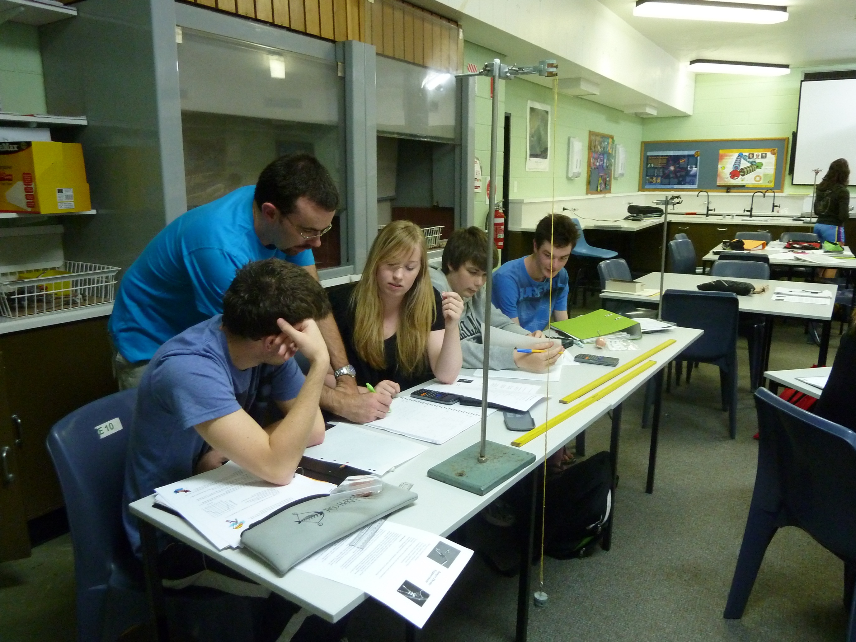*Hellyer College*

*School Improvement Plan*

*2013-2016*



Version 8.0 – 21 August 2014

Department of Education

Hellyer College

**Hellyer College Strategic Plan 2013-2016**

**Our Mission** - Hellyer College provides students with the opportunity to continue to learn and reach their potential, to lead fulfilling and productive lives and to contribute positively to the community

**Vision** - Successful, qualified and skilled young people prepared to be successful in tertiary and further education and training or employment post Year 12.

**Values** *Learning* - supported learning, independent learning principles, lifelong learning *Excellence* - in achievement, creativity, innovation, and new thinking

*Equity and diversity* – we all have the right to challenging and enjoyable learning *Respect - ethical behaviour, responsibility, integrity, accountability*

*Relationships* – growth through strong connections and partnerships with our learners, their communities and the world

|  |  |  |  |  |  |
| --- | --- | --- | --- | --- | --- |
| Our Drivers | Successful Learners | Innovative workforce | Inspired Leadership | Dynamic Learning environments | Community Confidence |
| * Empower learners to set high expectations about their education and future aspirations. * Engage students through creative, innovative and supported learning. * Establish safe, flexible and engaging learning environments * Develop 21st century skills and independent learning principles. * Establish enrichment programs and holistic learning programs to enable students to contribute to their community. | * Create a highly qualified and motivated workforce through strong professional development * Implement strategies to enhance the health and well-being of staff * Provide staff with regular feedback on their performance * Enable staff to enhance their professional practice. | * Promote a culture of inspiring leadership * Provide professional learning, coaching and mentoring for all staff * Encouraging a culture of innovation and continuous improvement. * Enhance leadership development and performance management across the DoE. | * Work collaboratively with TasTAFE, Flexible Learning Network and other providers to support the pathways and needs of our learners. * Work with all our associated high schools and in particular with our rural schools to support the co-delivery of Y11/12 programs in their schools. * Provide the resources and learning through the PiL Alumni to continue our journey as a Microsoft School, and facilitate more flexible and innovative teaching practices using ICT. | * Use data to inform our practice that is measurable and focussed on continuous improvement * Develop strong communication processes with the community about the work of Hellyer College * Celebrate student achievement with our associated schools, TasTAFE, UTas and our community. * Provide meaningful feedback and reports to parents about student progress. * Encourage community involvement at Hellyer College |

|  |  |  |  |  |  |
| --- | --- | --- | --- | --- | --- |
| Our Priorities | Ensuring Purposeful Pathways and Successful Transitions | Fostering High Quality Teaching | Encouraging High Attendance and the Successful Completion of Y12 | Improving Student Qualifications | Implementing National and State Curriculum Initiatives |
| * Strong partnerships with our associated high schools * Strong connections with industry, UTas, TasTAFE and other VET providers. * Career education and pathway planning for all students * Comprehensive orientation and course selection process for all students * Effective and targeted taste of college and transition programs | * Supporting collegial networks and Learning Area Teams * Implementing DoE Personal Development Plans using coaching model * Professional Learning for staff linked to college goals | * Whole college focus on improving attendance and retention * Student support staff work to support the work of teachers * Retention team working with students with attendance issues * Tracking of students of selected students * Provide alternative learning programs for disengaged students. * Extra support for rural students | * Ensuring all students achieve either a vocational qualification or an ATAR. * Ensure all students achieve the TCE. | * Supporting course development work with TQA * Enhancing teachers knowledge and understanding of new curriculum content * Encouraging the development of contemporary teaching strategies within the context of new curriculum initiatives. * Working with our associated high schools to ensure seamless curriculum delivery for students. |

**Hellyer College Operational Plan 2013**

|  |  |  |  |  |  |  |
| --- | --- | --- | --- | --- | --- | --- |
| **Priority 1- Ensuring Purposeful Pathways and Successful Transitions** | | | | | | |
| **Our Focus** | **Evidence/Data** | **Strategies** | | **Resources** | | **Targets/Measures of success** |
| Strong partnerships with our associated high schools, and other Further Education providers in the best interests of our students  Effective and targeted taste of college and transition programs in conjunction with associated high schools  Driver- Successful learners | TQA Data for 2012 is shared with high schools  Y 9 Naplan Data and Y10 English/Maths results for Y10 cohort is shared with college teachers  Aspirational Course Counselling - courses which result in an ATAR or Cert 3+ vocational qualification | Course changes- consider the previous plans and results  Ongoing monitoring and support for students undertaking courses in the TasTAFE/ Regular liaison with the Hellyer College and TasTAFE  College Principal leads regular communication with Principals of our associated high schools, and Leaders of Cradle Coast Campus of UTas and Burnie/ NW TasTAFE  ‘Thinking about Hellyer”- new program initiative to add to other transition program schedule | | AP- Transition  Course Counselling Team  VET Management Team  Careers’ Officer  Pathway Planning Officer  Guaranteeing Futures Team | | Average ATAR Scores improve  No of students completing Cert 3 and Diplomas for TasTAFE and Hellyer College  Positive feedback from high schools, parents and students about the preparatory college programs |
| Career education and pathway planning for all students  Strong staff connections with industry, UTas, TasTAFE and other VET providers | Improved teacher understandings of career and pathway planning.  Recent improvement of number of students transitioning directly from Hellyer College to university  Hellyer teachers learn from FE, industry and employers | University Trips for Hellyer students   1. Visual Arts 2. Science/Maths/Engineering 3. Humanities   UTas and Interstate university forums at Hellyer College  Assisting in transition to university , employment, youth service providers and other education providers.  Hellyer Stage 2 in 2013teachers in industry program  VET teachers in industry for 5 days in November to update their knowledge, skills and understandings. | | HEPP program  Support teachers  UTas staff working at Hellyer  AP- Staff Professional Learning  Retention Team  Burnie City Council/Hellyer College Association  Hellyer Careers Officer  Principal involvement with the LAG | | All students receive career and pathway planning  % of students who successfully complete the 50 hour TQA course, Personal Pathway Planning by the end of Year 12.  % of students continuing with FE, including university transition rates is maintained.  Changed attitudes towards the value of education and training programs at Hellyer College by employers and the community |
| **Priority 2- Fostering High Quality Teaching** | | | | | | |
| **Our Focus** | **Evidence/Data** | | **Strategies** | **Resources** | | **Targets/Measures of success** |
| Supporting collegial networks and learning area teams to aligning teaching practice to C21st skills. | Regular meetings between LA’s within the college and across the college system with a focus on teaching, learning and assessment and Quality Assurance. | | Calibration and assessment in teams  Sharing of teaching resources  ACARA and other course development work | AP- Teaching and Learning  Learning Area Leaders  CTL’s across the college system | | Staff Feedback and documentation reflecting the QA work.  TQA Data about individual classes.  Staff and parent survey results |
| Staff PDP’s are developed with the aim of improving professional practice | The completion of  PDP’s for all staff; the engagement of staff in at least 2 professional conversations with a senior staff person. | | Skilling and practicing ‘cognitive coaching’ with the coaches  Align discussion with the School Improvement Plan and the AITSL Framework, in particular Standard 3. | AITSL tools and standards  2012 PDP’s  Hellyer College Student Feedback Tool | | PDP’s are completed and the majority reflect the focus on improving teacher practice and inform the basis of staff development and inform professional learning needs |
| Professional Learning for staff linked to college goals | PL Application process. | | Major areas of focus for PL-Individualized, small group and whole school, college network. | PLI- leadership programs  AP Teaching and Learning  In-house and other staff expertise  CTL’s | | That a survey of PL provided for staff reflects the goals of the college.  PL approvals outline link with the college goals and their current work |
| **Priority 3- Encouraging High Attendance and the Successful Completion of Year 12** | | | | | | |
| **Our Focus** | **Evidence/Data** | | **Strategies** | **Resources** | **Targets/Measures of success** | |
| Improving student attendance | Daily Student Attendance Data | | Strong community messaging about the importance of attendance  Implementation of 2014 Attendance Policy Term 3 – Hellyer Staff Intranet -> Policies and Plans -> Attendance Policy  Provide summary attendance data to support teachers for their students through Edi fortnightly  Text msgs to parents and follow up by the support teacher. 1st and 2nd Term only. Review use of text messages for 2015  Case Management of students at risk by the Retention Team.  Work closely with Centrelink  Retention team to monitor students with attendance under 85% through Edi with automatic letter trigger  Identify students with poor attendance in Grade 10(Inform teachers) | All staff and parents  Careers advisor  Support teachers monitor attendance of a small group of students  Creating Connections  AP/AST Retention to Implement new Attendance Policy with staff  Centrelink  Designated Retention Team to work with Y11 students at risk of disengaging from education  Hands on subjects | % of students who are attending 50% or less is reduced  % of attendance letters being sent lessens  Keeping daily attendance above 80% | |
| Improving student retention | Transition data from Year 10-11  Transition data from Year 11-12  Transition data from school/college to TasTAFE.  Data about early leavers from Hellyer College  Apparent Retention Rate- Tracking the whole cohort Data  Process for course changes to support student engagement and success with their learning. | | Student support staff align their work with teachers  The increased participation of outside service providers working at the college and with our students work  Track students who leave/do not arrive at college to discern if destinations are of a positive nature.  Breakfast Club  Drug and Alcohol Case workers  Doctors’ Clinic  Support staff  Creating Connections  Retention team  Support Group time | All staff  Retention Team  YLO in Term 1 and 2  Student Support Team  Pathway Planning Officers in high schools  YTO (Anita)  Careers advisors | Community message about the completion of Year 12 is strong  Transition data from Year 10-11 is maintained  Transition data from Year 11-12 is improved-  Student pathways from Year 11 and 12 are into TasTAFE, employment and UTAS  Transition and attainment data from school/college to TasTAFE is monitored. | |
| Reducing the barriers and disincentives for rural and isolated students to have equal access and participation | % of students who are successfully completing FLN courses is low  Rural schools have limited range of courses and subjects.  Rural schools currently have difficulty accessing expertise within the senior secondary subjects/courses in their quest to deliver high quality learning.  Shortfall of student accommodation | | Shift from FLN to new Digital and E-Learning models are explored and monitored  Hub and Spoke Models  Flexible timetabling  Transport that supports participation at Hellyer  Accommodation | FLN teachers  Equipment and teacher resourcing at Hellyer College and | Successful enrolment of students and their completion of courses using an E-Learning Feedback from teachers and students mode of study.  Increased collaboration with teachers from Hellyer College and their associated schools that have Year 11/12 students. | |

|  |  |  |  |  |  |
| --- | --- | --- | --- | --- | --- |
| **Priority 4- Improving Student Qualifications** | | | | | |
| **Our Focus** | **Evidence/Data** | **Strategies** | **Resources** | | **Targets/Measures of success** |
| Improving the number of  students achieve the TCE | TQA Data on TCE achievement | Allocate an AST with responsibility to identify students at risk of not achieving ticks for the  TCE.  -Identify students who failed a subject in Y11  -Identify students who do subjects that do not secure the TCE ticks for literacy, numeracy and ICT  -Implement a range of strategies for these students  -Education for parents and staff | AP- TQA  AST - Maths  Enrichment programs for students at risk of not gaining their TCE- One line release for Enrichment planning  The TQA Tests  All students enroll in the subject Personal Pathway Planning | | The number of Hellyer College Y12 students in 2013 who gained the TCE is greater than the number of students in 2012.  The % of students of Hellyer College gaining a TCE is equivalent or above the state average for government colleges (45% in 2012) |
| Students are attaining either   * higher level VET qualifications and/or * higher ATAR’s | The % of students at Hellyer College studying one TQA3 subject in 2012 is currently 68% compared to 59% for Tasmanian government schools.  The average ATAR for Hellyer is 73.4 and 76.2 for Tasmanian government schools. | TQA data analysis and improvement goals identified for  all Learning Area Leaders and individual teachers. | AP’s –Curriculum  TQA Subject, class and teacher specific data. | | The % of students at Hellyer College studying one TQA3 subject in 2013 is maintained or  improved  The average ATAR scores for Hellyer College students is similar to other Tasmanian government schools. |
| To extend the scope of the partnership agreements with our associated rural schools to assist with senior secondary subjects/courses for Y11/12 students who are enrolled in these schools. | PA’s represent tailored approaches that consider local needs and barriers.  Explicit statements about direction and intent, the action that will be taken, when, how and by whom. | To develop PA’s with associated rural schools to support student achievement in these schools. | Provide teaching resources (people, teaching and learning materials, assessment and QA requirements) to support this goal.  Introduce new technologies to support this goal | | Satisfaction by High school Principals and Hellyer College Principal with the PA’s. |
| Equity Projects to improve student outcomes for targeted groups  Develop more retention programs and more clearly defined support for students at risk of disengagement | Collection of data about our rural students occurred in 2012  Transition Education program | National Partnership Low SES project identifies strategies to work collaboratively with   1. WHS 2. PHS 3. YDHS   NP  NP Young Mothers’ program at C&FC in Acton  Teacher PL for DSE in November | College and identified NP funding for   * Aboriginal Leadership Program (teacher 1 line) * Young Mothers’ program (Teacher 0.25) * The Hub (1 teacher and 1 TA 0.6 FTE) * Attendance Case Management program(Youth Worker 3 days a week) * Retention Team program * Literacy program | | TQA Student Results for rural students matches our urban students  TQA Student Results for aboriginal students matches all students- % of Aboriginal students gaining an ATAR increases  TQA Student Results for students who are parents is monitored  The % completion of students participating in equity programs |
| **Priority 5- Implementing National and State Curriculum Initiatives** | | | | | |
| **Our Focus** | **Evidence/Data** | **Strategies** | | **Resources** | **Targets/Measures of success** |
| Enhancing teachers’ knowledge of new curriculum content and supporting course development work with the TQA, including those with ACARA content, and ASQA. | Participation by staff in the writing, review and implementation of new subjects and vocational courses. | Supporting and encouraging teachers to participate in this work. | | 9-12 Curriculum Teacher Leaders  LAL’s  AP- TQA Co-ordinator | Successful implementation of new subjects and courses.  Staff involved in working teams at the local and state level. |
| Supporting teachers to adopt contemporary teaching strategies within the context of new curriculum initiatives. | QA Meeting Agendas and Minutes | Staff are provided with the opportunity to explore innovative pedagogy, using ICT in particular  Quality Assurance Processes | | AP- Teaching and Learning | Teachers are using a greater variety and more innovative and appropriate teaching strategies |
| K-12 Focus for curriculum | Feedback from High School Principals  Participation in teacher meetings | Encourage staff to participate in high school moderation processes, with Geography and History as a main priority for 2013-2014.  Continue to collaborate with our associated high school 9-10 teachers for ACARA Math, Science and English curriculum synergies. | | AP-Teaching and Learning  AST Math, Science and English. | Seamless transition from Year 10-11 as feedback reported by college teachers |
| Literacy |  | Identifying the subject specific Literacy demands.  Skilling all teachers to explicitly teach subject specific literacy skills.  Assist students to transfer their literacy skills from one subject to another  AST/ English to train 20 staff in “How Language Works’ by December 2013.  Tutorials in Terms 2 and 3 for targeted students | | Principal to undertake SPALL  Literacy and Numeracy Framework to develop leadership strategy  AST Engish  “Supporting Literacy and Numeracy Success”  Literacy Teacher to have a line release  Learning Area Leaders to do collaborative planning with staff | Increase the proportion of students gaining the TCE  Close the gap for students who need it  Preparation for students doing TQA3 subjects in Year 11 that ensures their success  20 staff complete the How Language Works training.  Principal connects SPALL and the initiatives led by teachers. |
| Numeracy | TCE Numeracy data/TQA data.  Numeracy remains a barrier for students. The continuum ranges from those who are doing demanding Mathematics subjects/courses for the first time through to students who remain behind in their year level, as determined by Naplan testing.  Literacy is a barrier to being numerate. | Flexible program has been developed for students who are not doing a subject that will meet numeracy requirements of the TCE.  PL for Maths teachers to learn about pedagogy.  Whole staff PL in literacy and numeracy-spaced learning program  Assist students to transfer their numeracy skills from one subject to another. | | AST Maths  CTL- Numeracy | Increase the proportion of students gaining the TCE  Close the gap for students who need it  Preparation for students doing TQA3 subjects in Year 11 that ensures their success |
| Using technology for powerful teaching and learning and contribute to the development of a State E- Learning Strategy. | New Pedagogies Survey provided baseline data about staff and students use of technology in teaching and learning | Begin implementation of New Pedagogies for Deep Learning  Trial use of Fronter for PPP by FLN and interested staff | | AP and AST leading learning utilising new pedagogies and linking with other College teaching and learning priorities | Use of New Pedagogies survey to gauge improvement in teacher use of ICT  % of students accessing learning resources out of class time and at home  Increase in teachers involved in New Pedagogies work |